**TMS HOTROD NATIONALS**

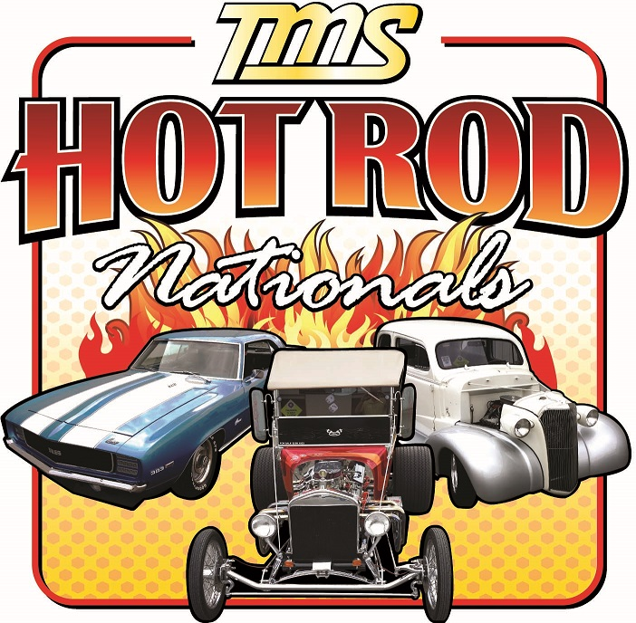

**October 3rd 2015 – 10am to 2pm**

**2440 Glendale Lane Sacramento, CA 95825**

**Vehicle Registration Form**

***\*\* LIMITED TO PRE 1973 VEHICLES \*\****

**Pre-Registration must be post marked by 09/18/2015. Pre-Registration fee $25. After 9/18 $30.**

**All registrants will receive one event t-shirt. The first 100 entries receive a swag bag with a dash plaque, one t-shirt, and two raffle tickets. Car show to benefit the US ARMY Warrant Officers Association, Gold Rush Chapter which provides aid to soldiers and airmen in need.**

**Name: ______________________________________ Address: ____________________________________**

**City/State/Zip: ____________________________________________ Phone: _________________________**

**Email: ___________________________________________________________________________________**

**Vehicle Make & Model: 19____________________________________________________________________**

**Shirt #1 Size: __________ Shirt #2 Size: __________ (Sizes: S, M, L, XL, XXL, XXXL)**

**Are you with a Car Club? If so, which one: ______________________________________________________**

**By accepting and participating in the car show, I hereby release TMS, US ARMY Warrant Officers Association, their vendors, members, officers, & anyone else connected with this event of any known or unknown damages, injuries, losses, judgements and/or claims from any causes whatsoever that be suffered by anyone participating in this event or by any spectators.**

**Signature: _______________________________________________ Date: __________________________**

**All vehicles must arrive before 9:30am. This is a Rain or Shine event. No refunds will be given as space is limited.**

**Additional T-Shirt Orders: S, M, L, XL = $16 / XXL, XXXL = $18 / Day of Event = $20**

**Sizes: ________ Number of Shirts:_________ Total: _________**

**There will be: Raffle Prizes, Awards, Trophies, Vendors, Food and an indoor Eating Area.**

**For Car Show Information: Tim Sproul (916) 539-2939 or www.tmscentral.com**

**Mail Entries to: TMS, 2440 Glendale Lane, Sacramento CA 95825**